

System Admin
Training Assignments

Program Code
Issue/Revision | x/y
Effective date | August 4, 2023
Assignment Day 01: Install Ubuntu 22.04

I. Download Virtualbox and ISO file Ubuntu 22.04
Download Virtualbox:
- https://download.virtualbox.org/virtualbox/7.0.10/VirtualBox-7.0.10-158379-Win.exe
Download Ubuntu 22.04:
- Homepage : https://releases.ubuntu.com/jammy/
- Guide link : Ubuntu 22.04.4 LTS (Jammy Jellyfish) https://docs.centos.org/en-US/centos/install-guide/getting-started/
- Ubuntu 22.04. 4 iso downloads: https://releases.ubuntu.com/jammy/ubuntu-22.04.4-live-server-amd64.iso

II. Create VM in Virtual Box
1. Click the 'New' button to create a new virtual machine.
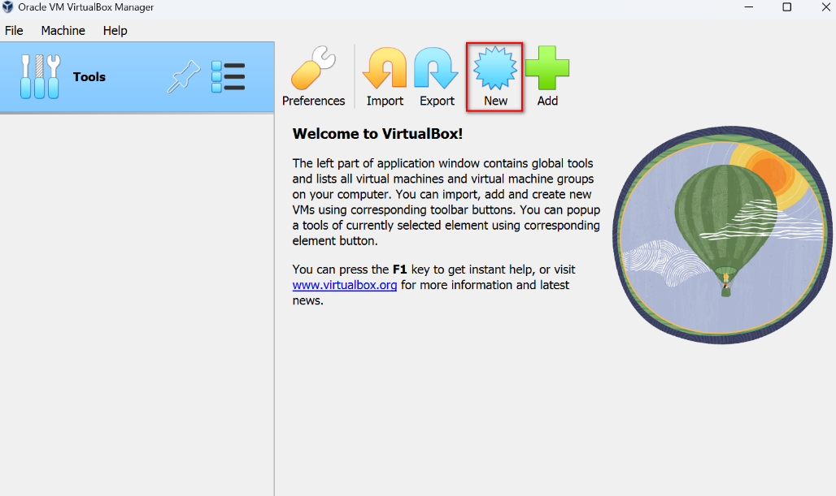

2. Write the machine name and set the machine type and version as indicated in the screenshot.
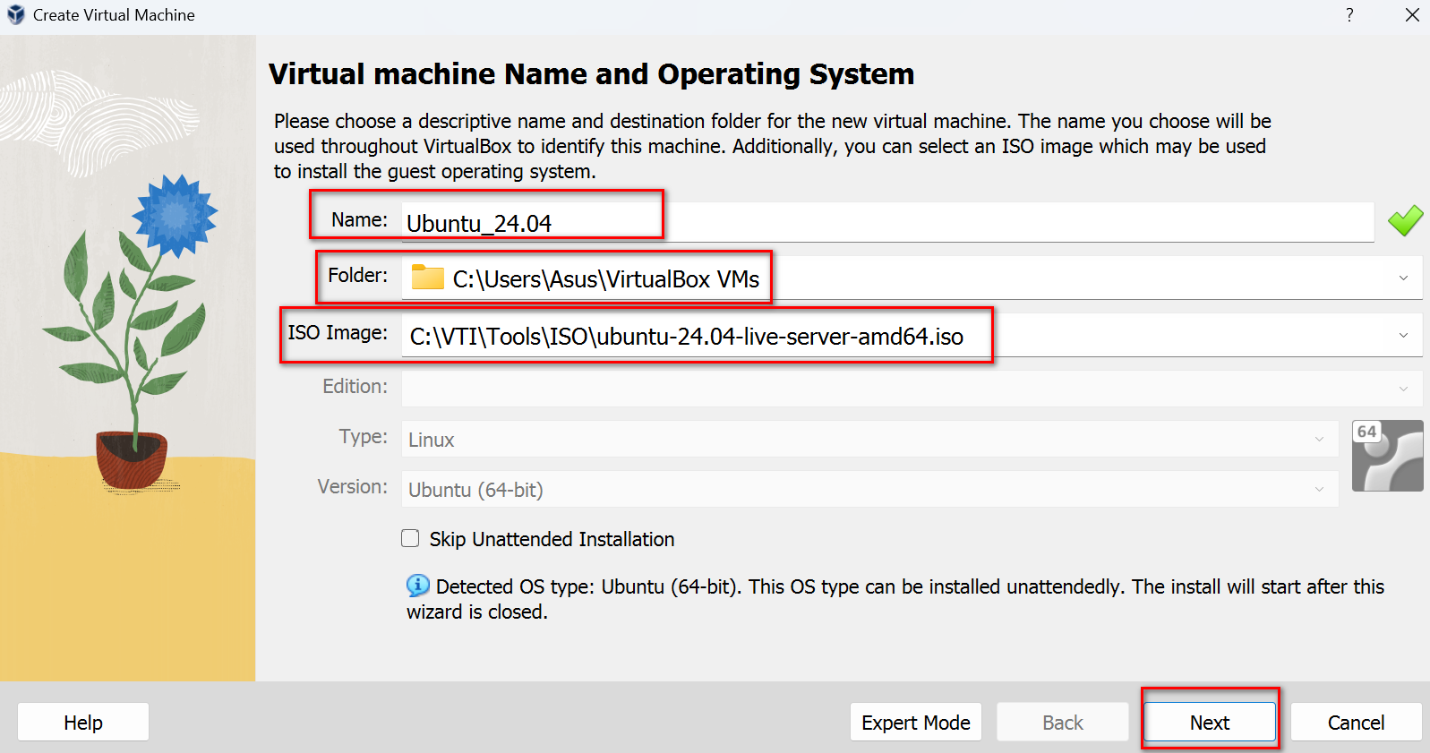

3. Set user/password, hostname then click Next.
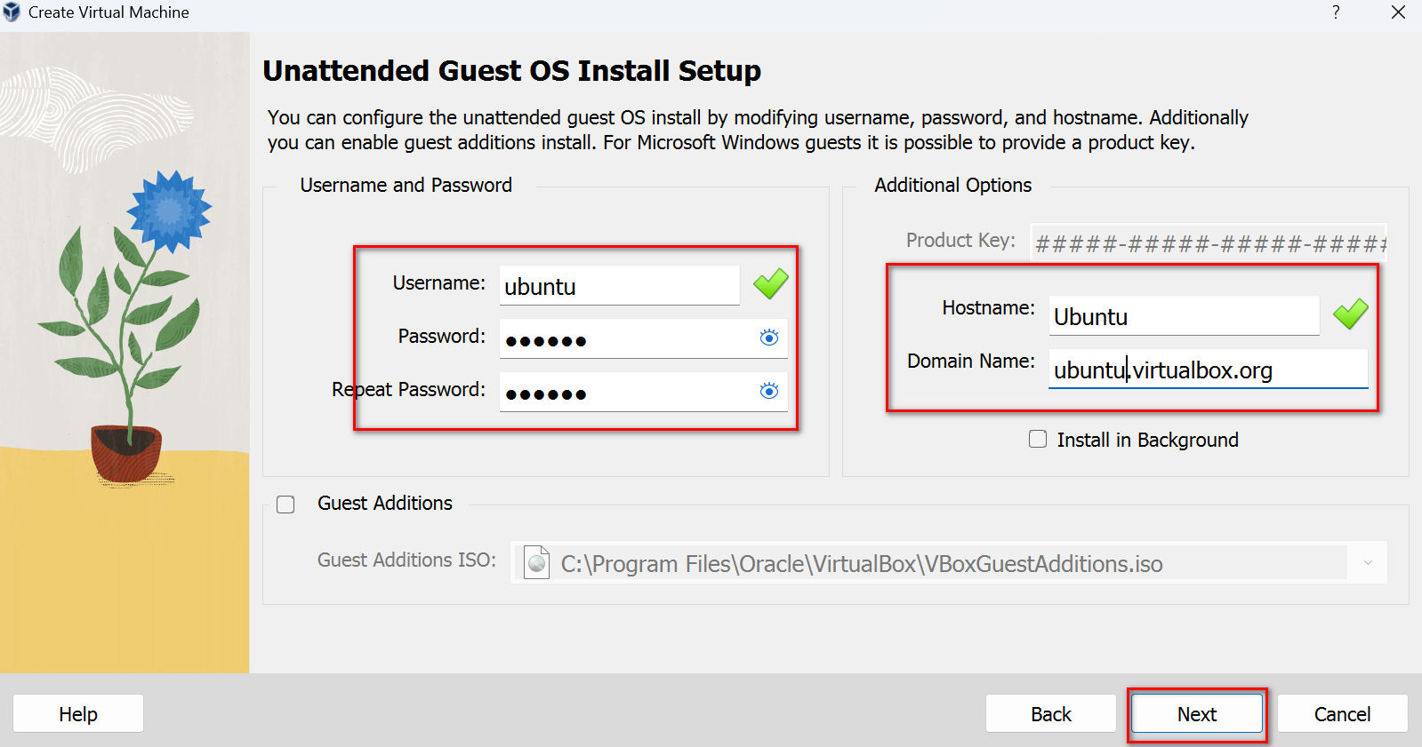

4. Now select CPU and RAM for the VM and click Next.
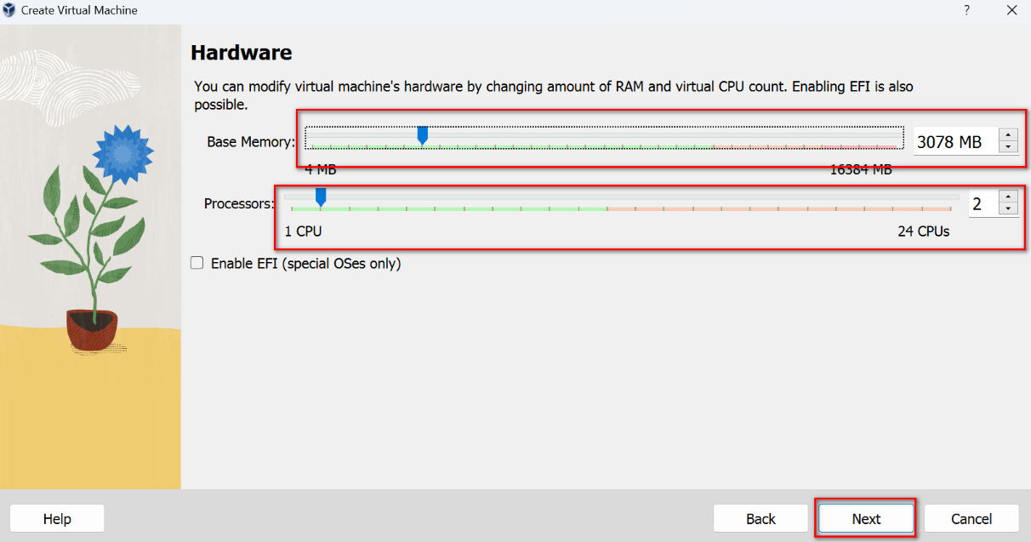

5. Choose the disk size and click Next.
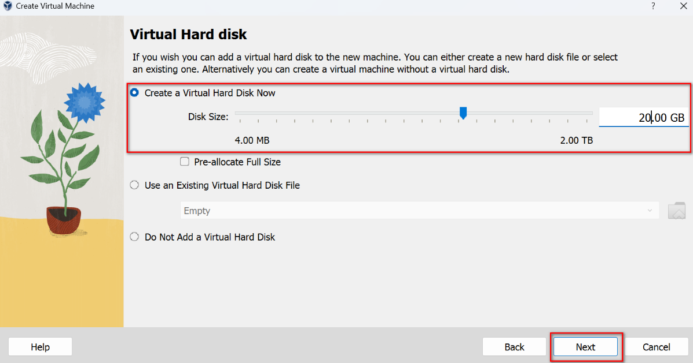

6. Check the summary and click Finish to start create the VM.
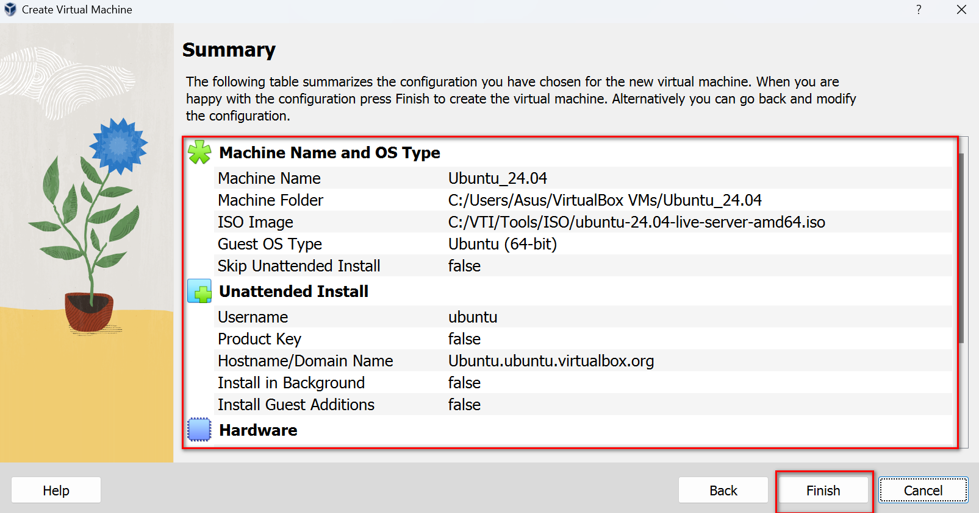

III. Install Ubuntu 24.04 operating system
Once the machine is booted, the Grub menu will appear, from there select the 'Install Ubuntu Server' option by pressing “Enter” to boot the machine.
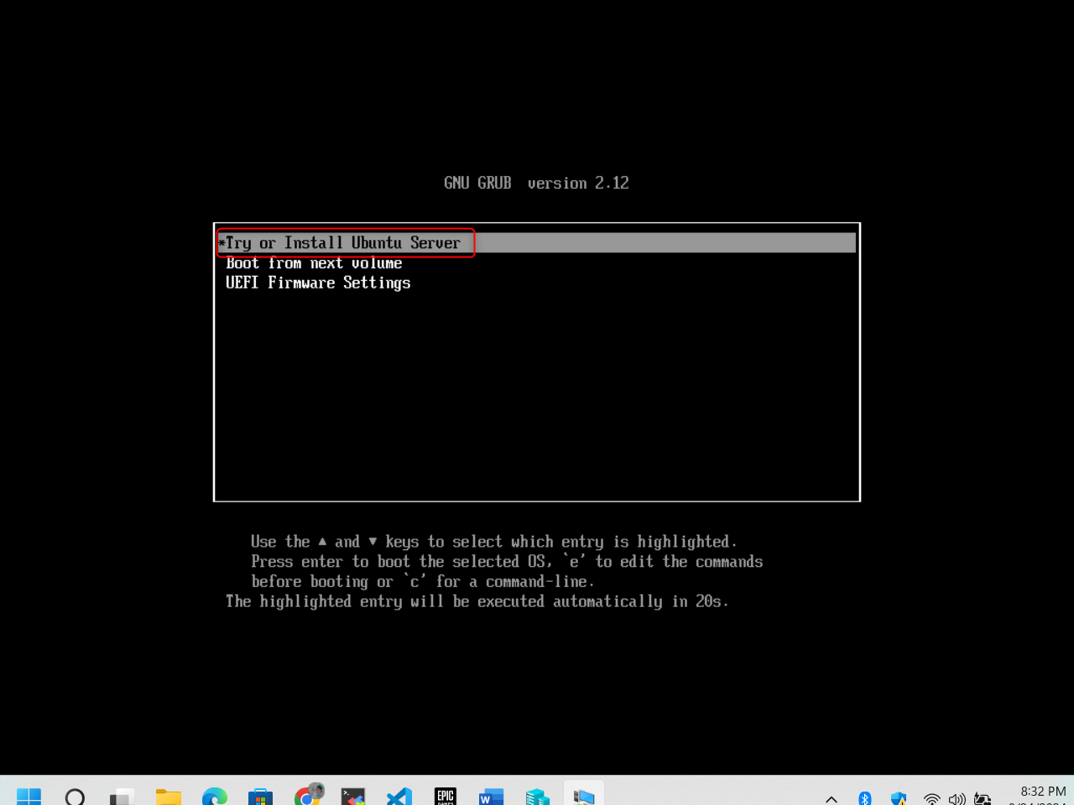

Choose “English” as language then press enter.
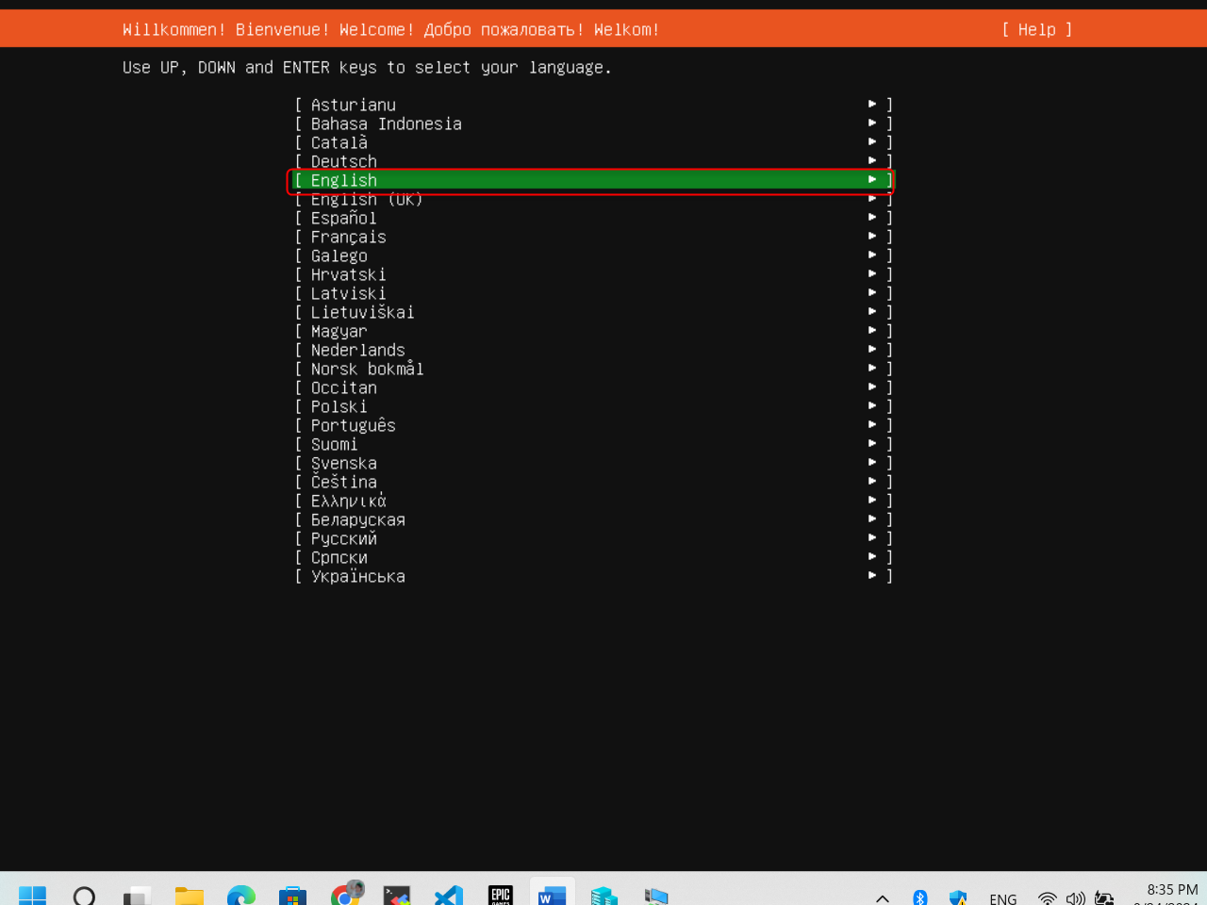

Choose “Continue without updating” and press enter
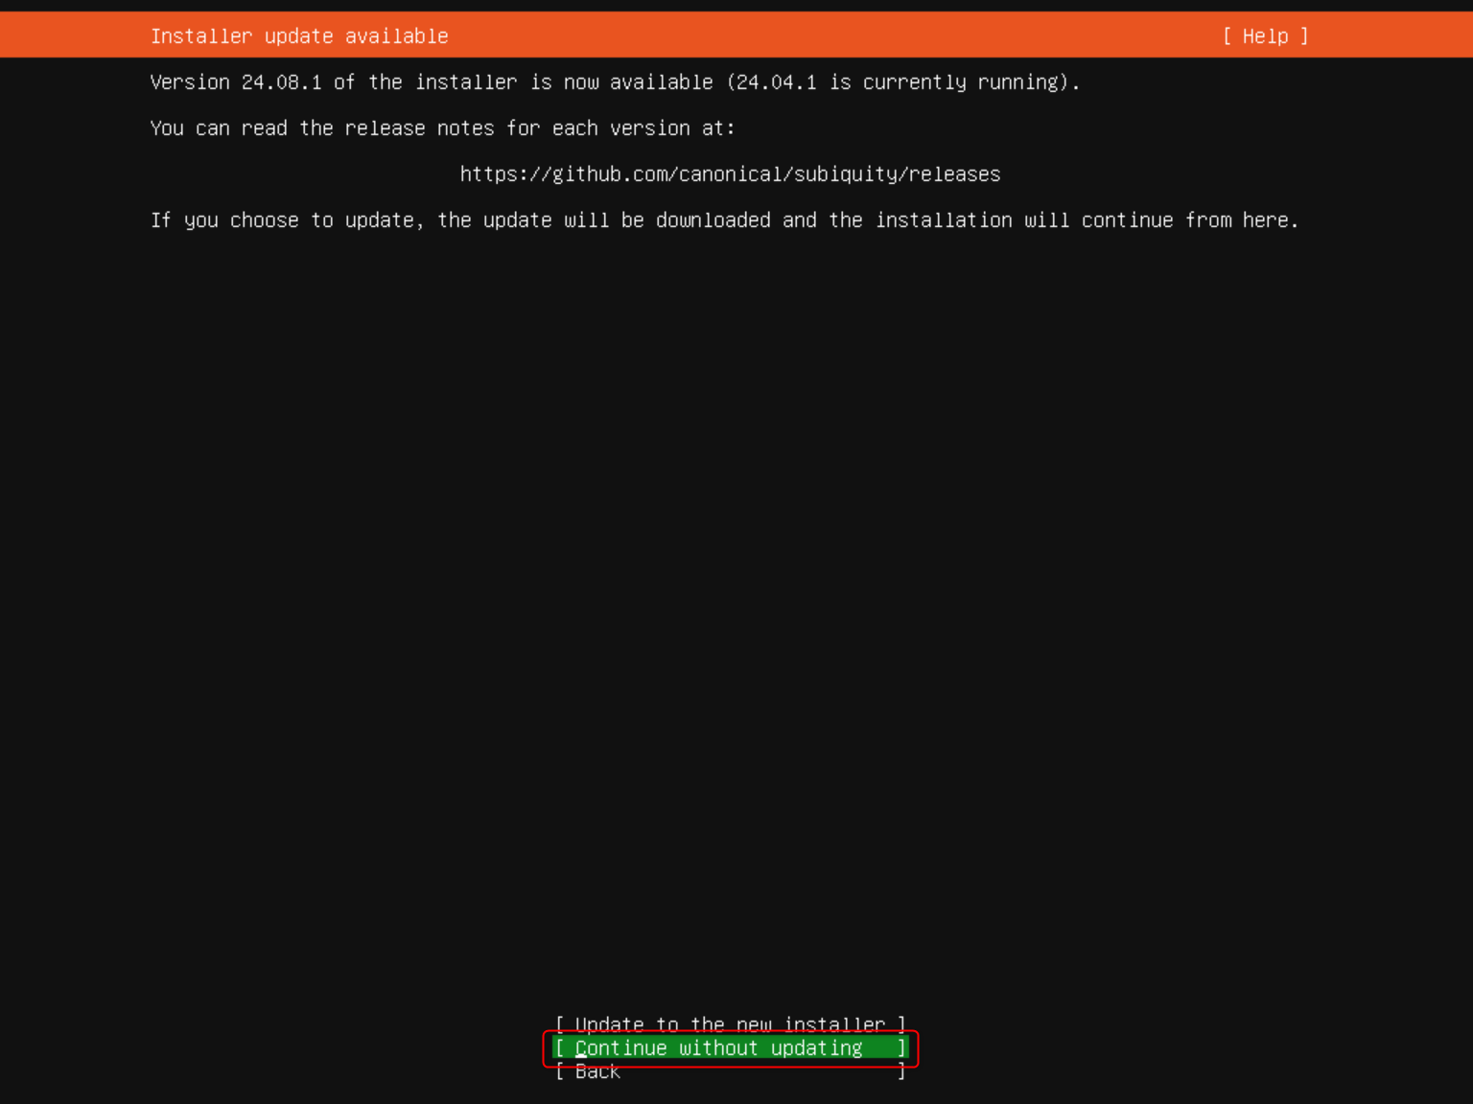

For the next steps, keep default options and choose “Done”
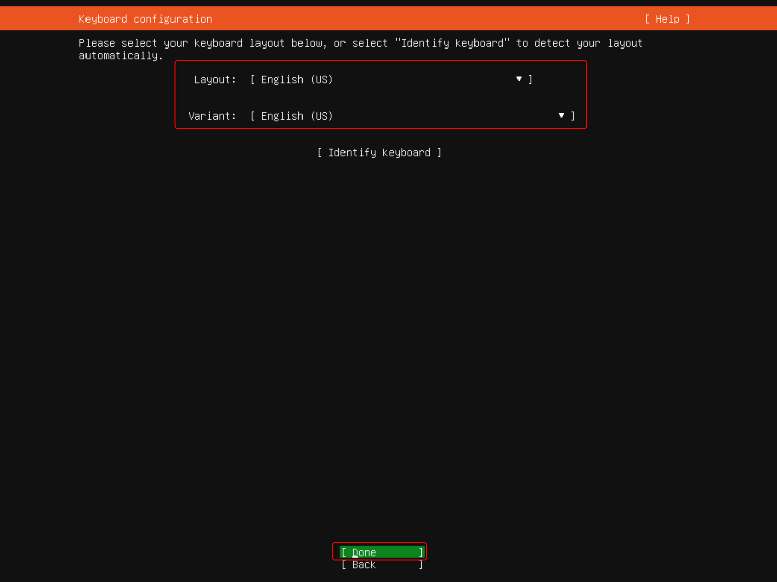
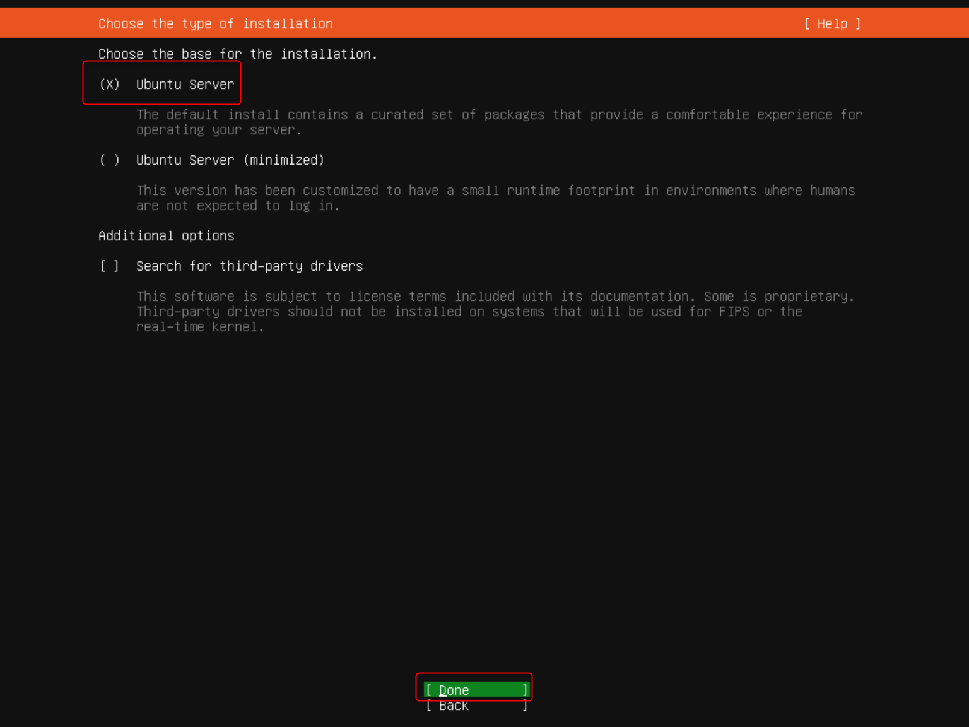

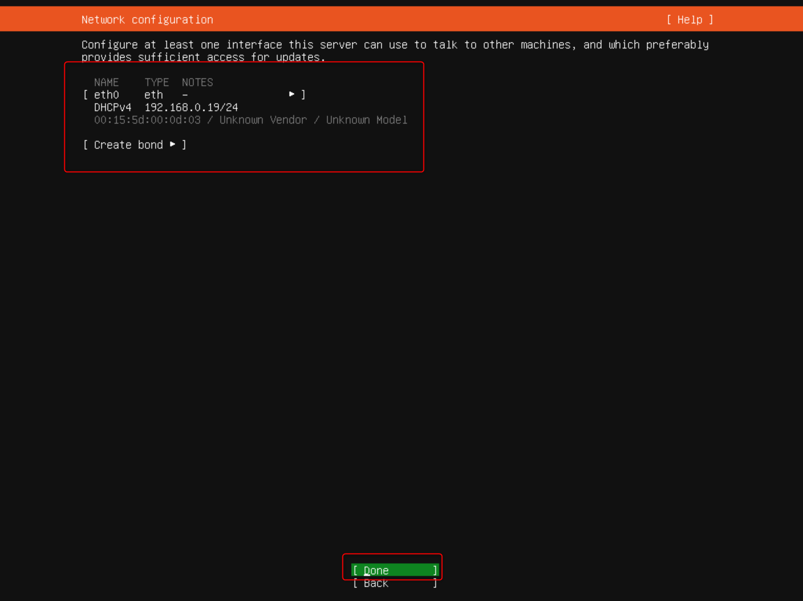
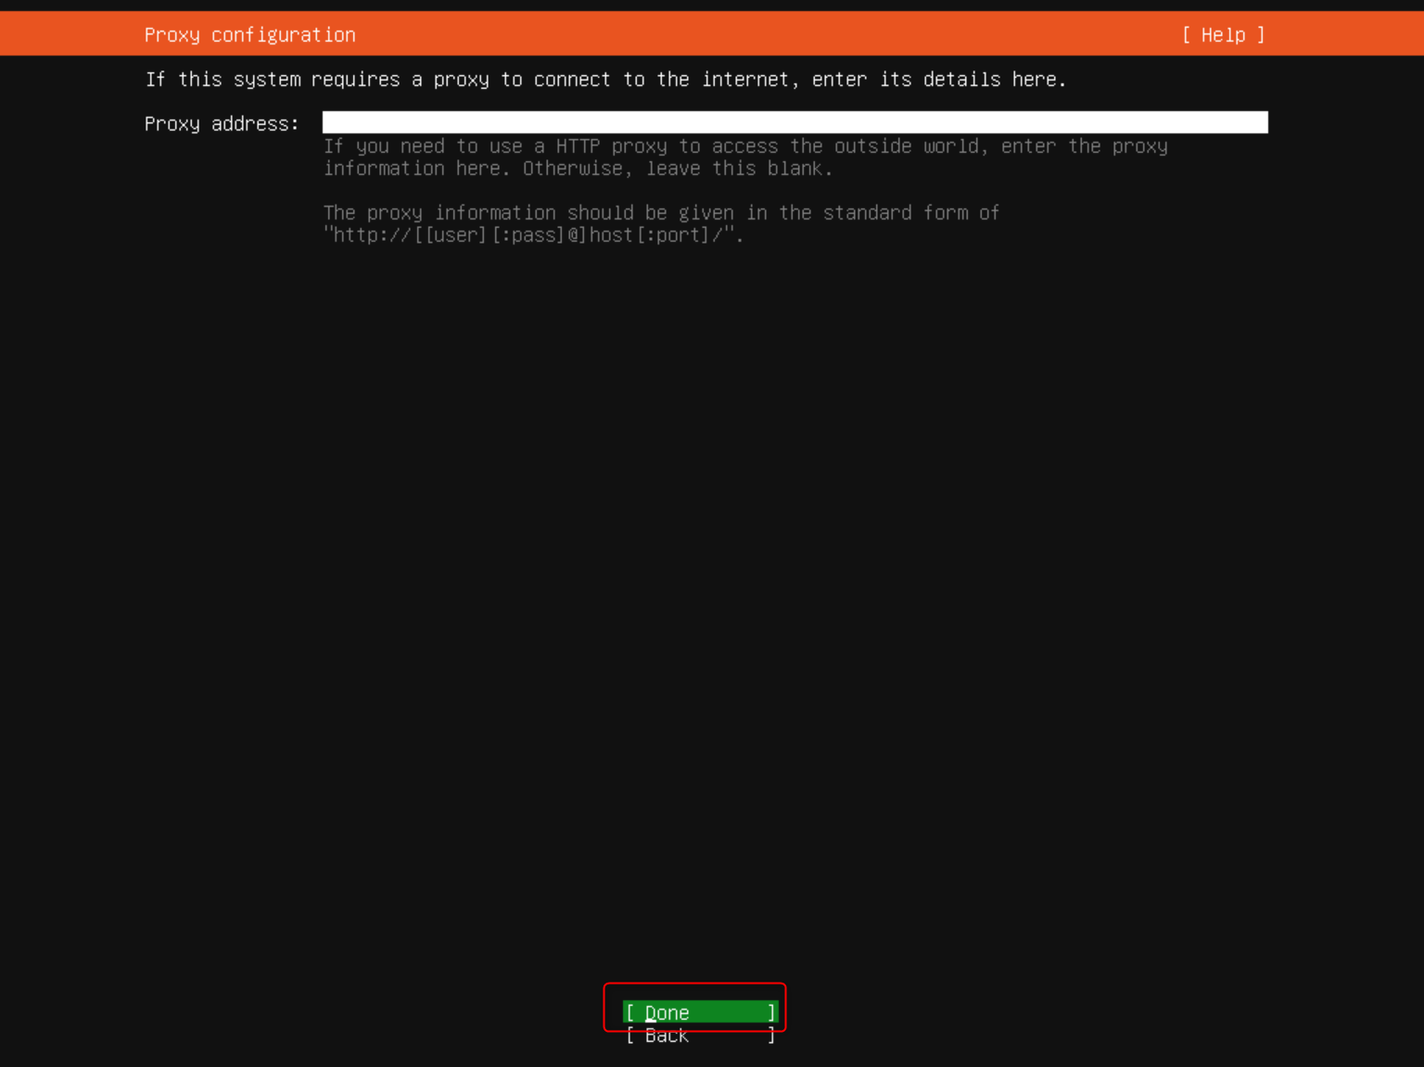
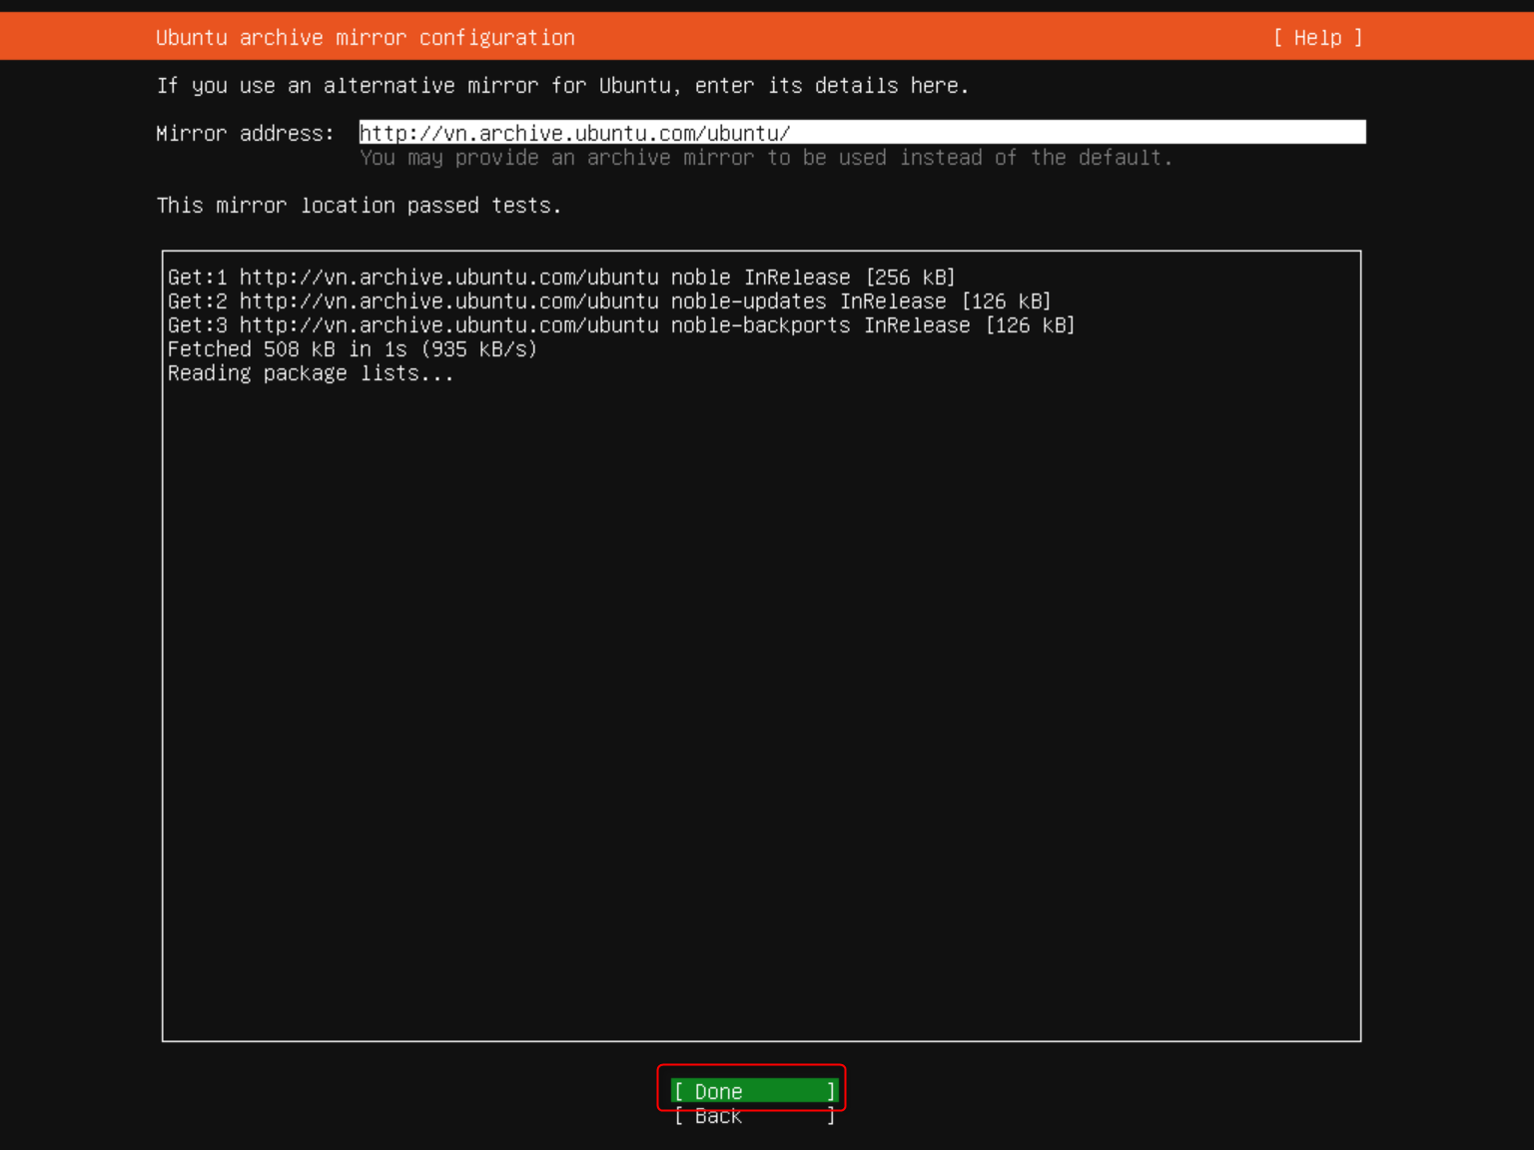
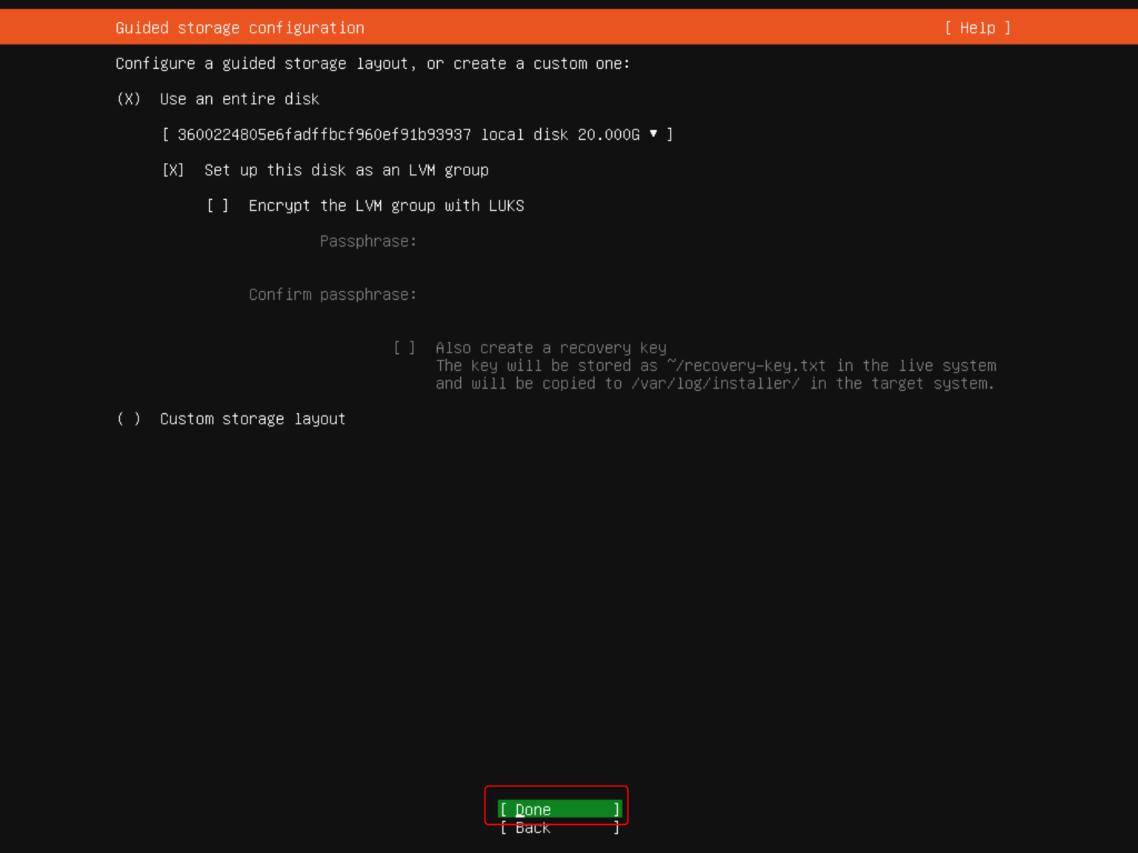

In this step, edit the “ubuntu-lv” to use the maximum size of the storage
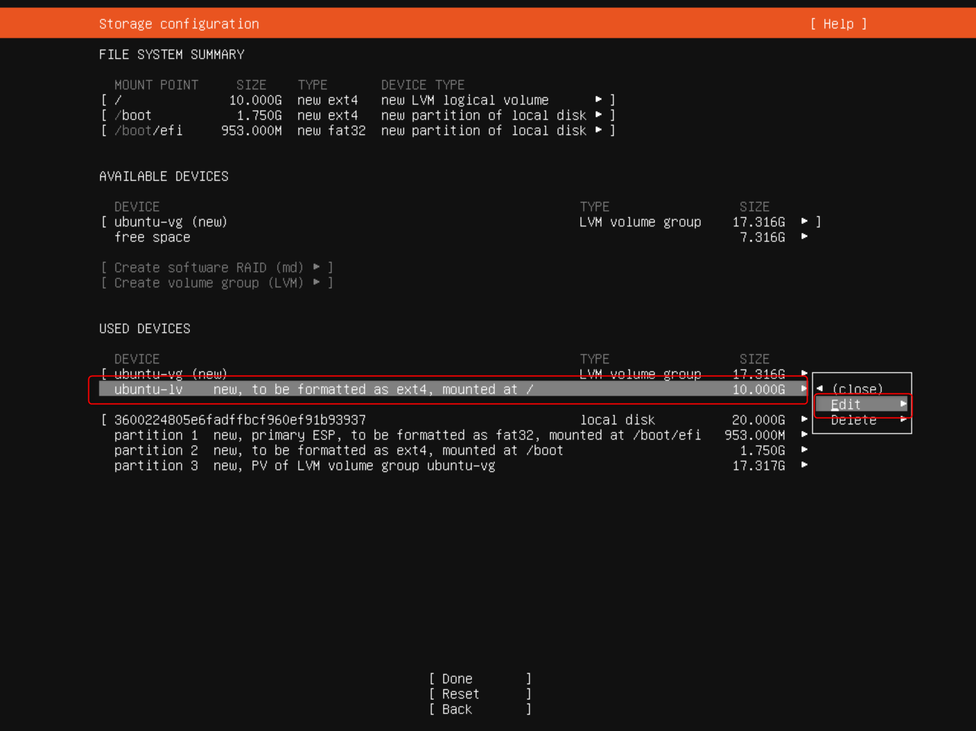
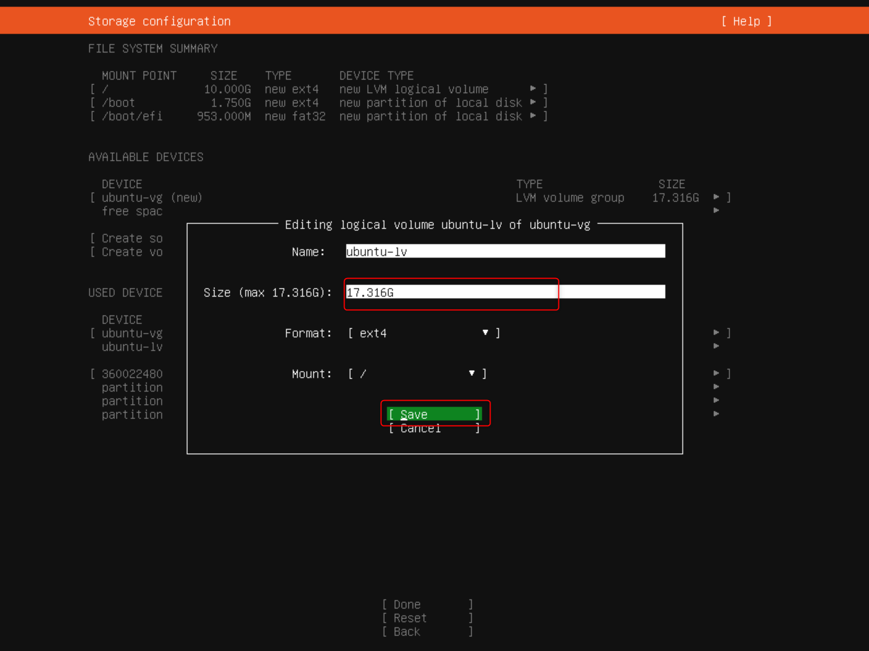
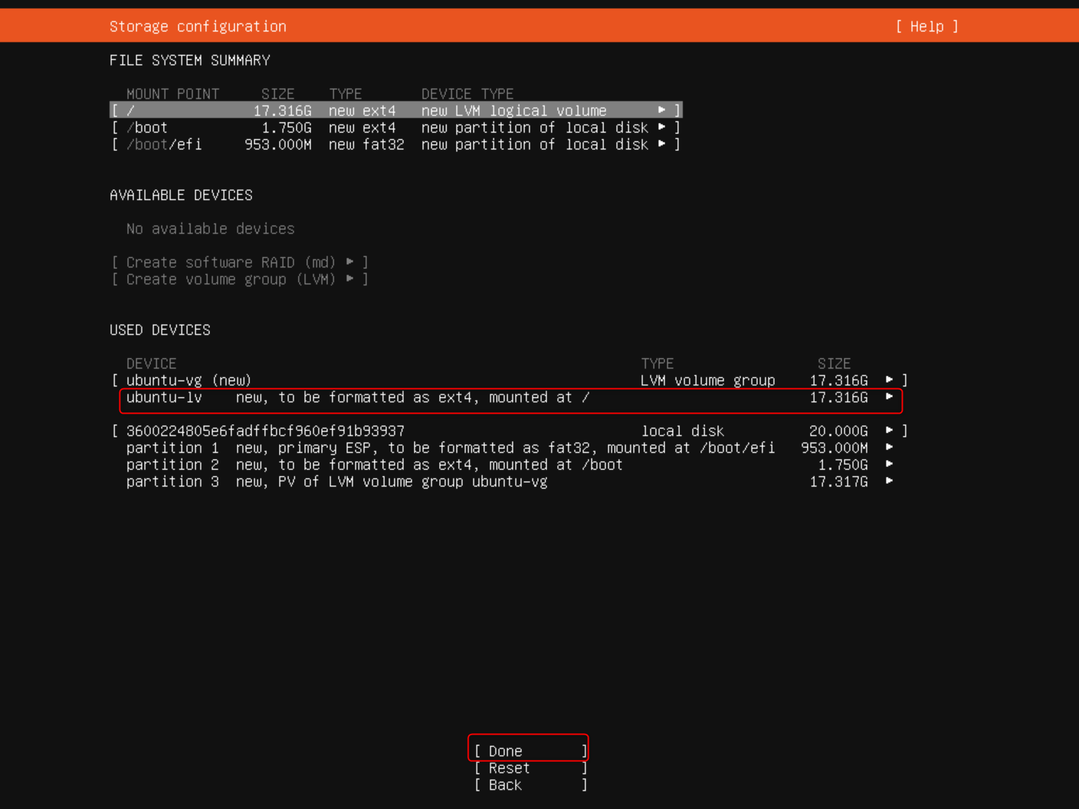

Input your server’s name, username, password and choose “Done”
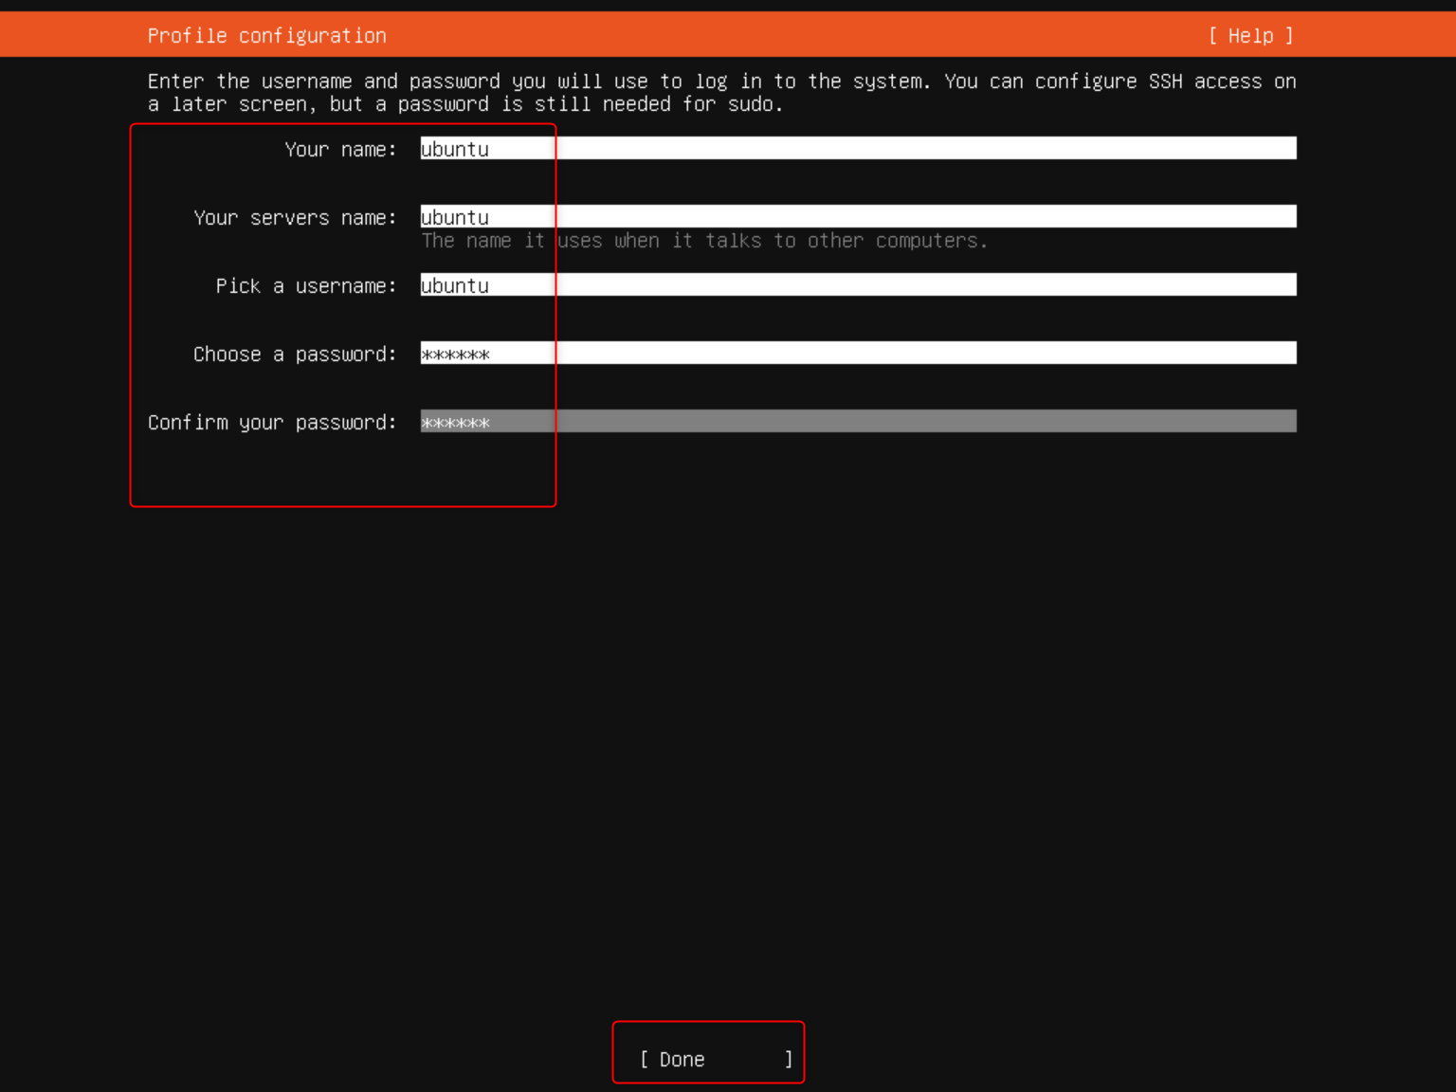
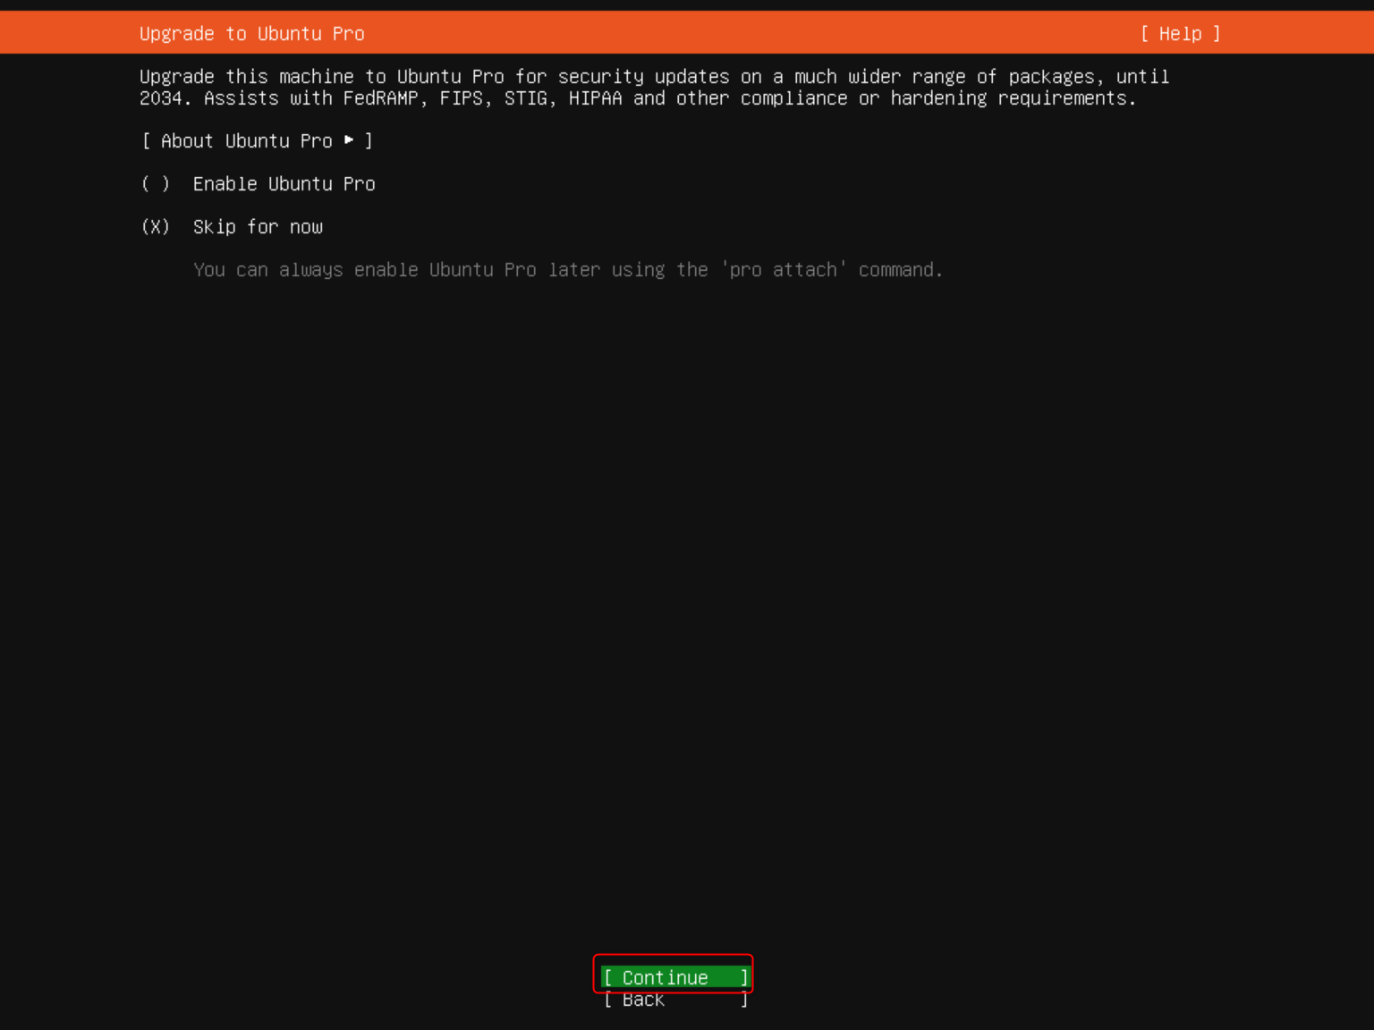

Choose “Install OpenSSH server” then choose “Done”
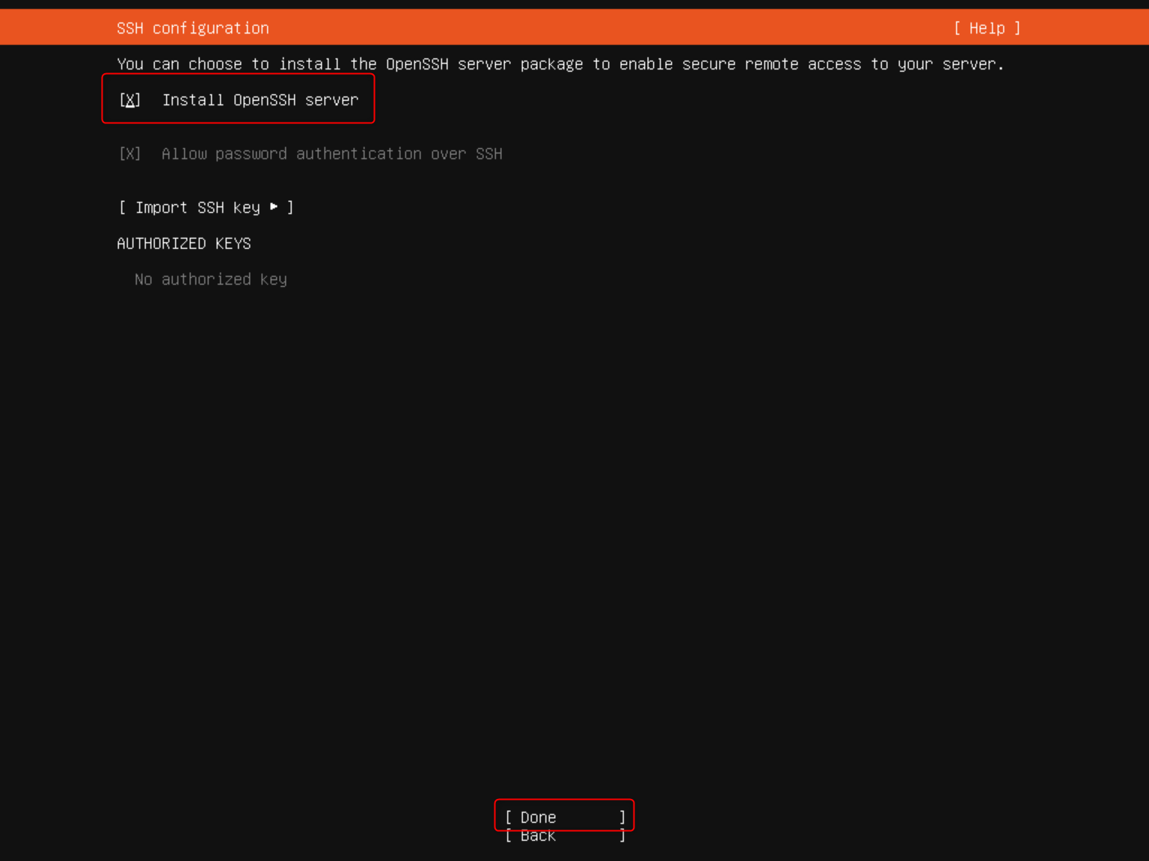

Skip all features then choose “Done” to start Install Ubuntu server
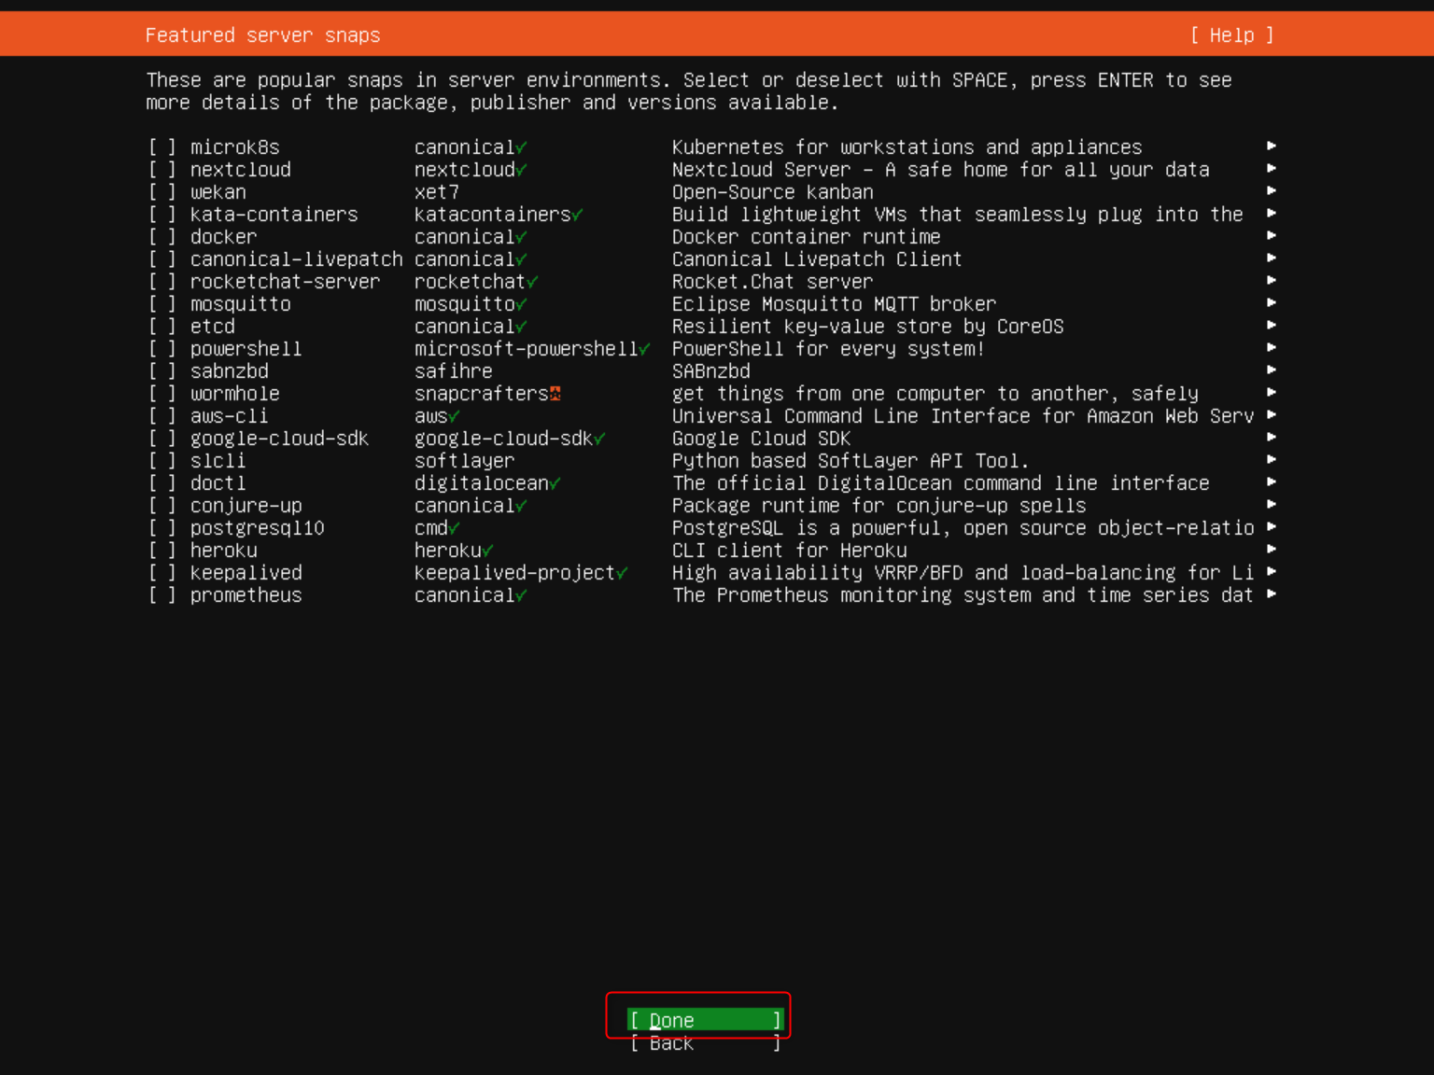

What for couple minutes to finish install server
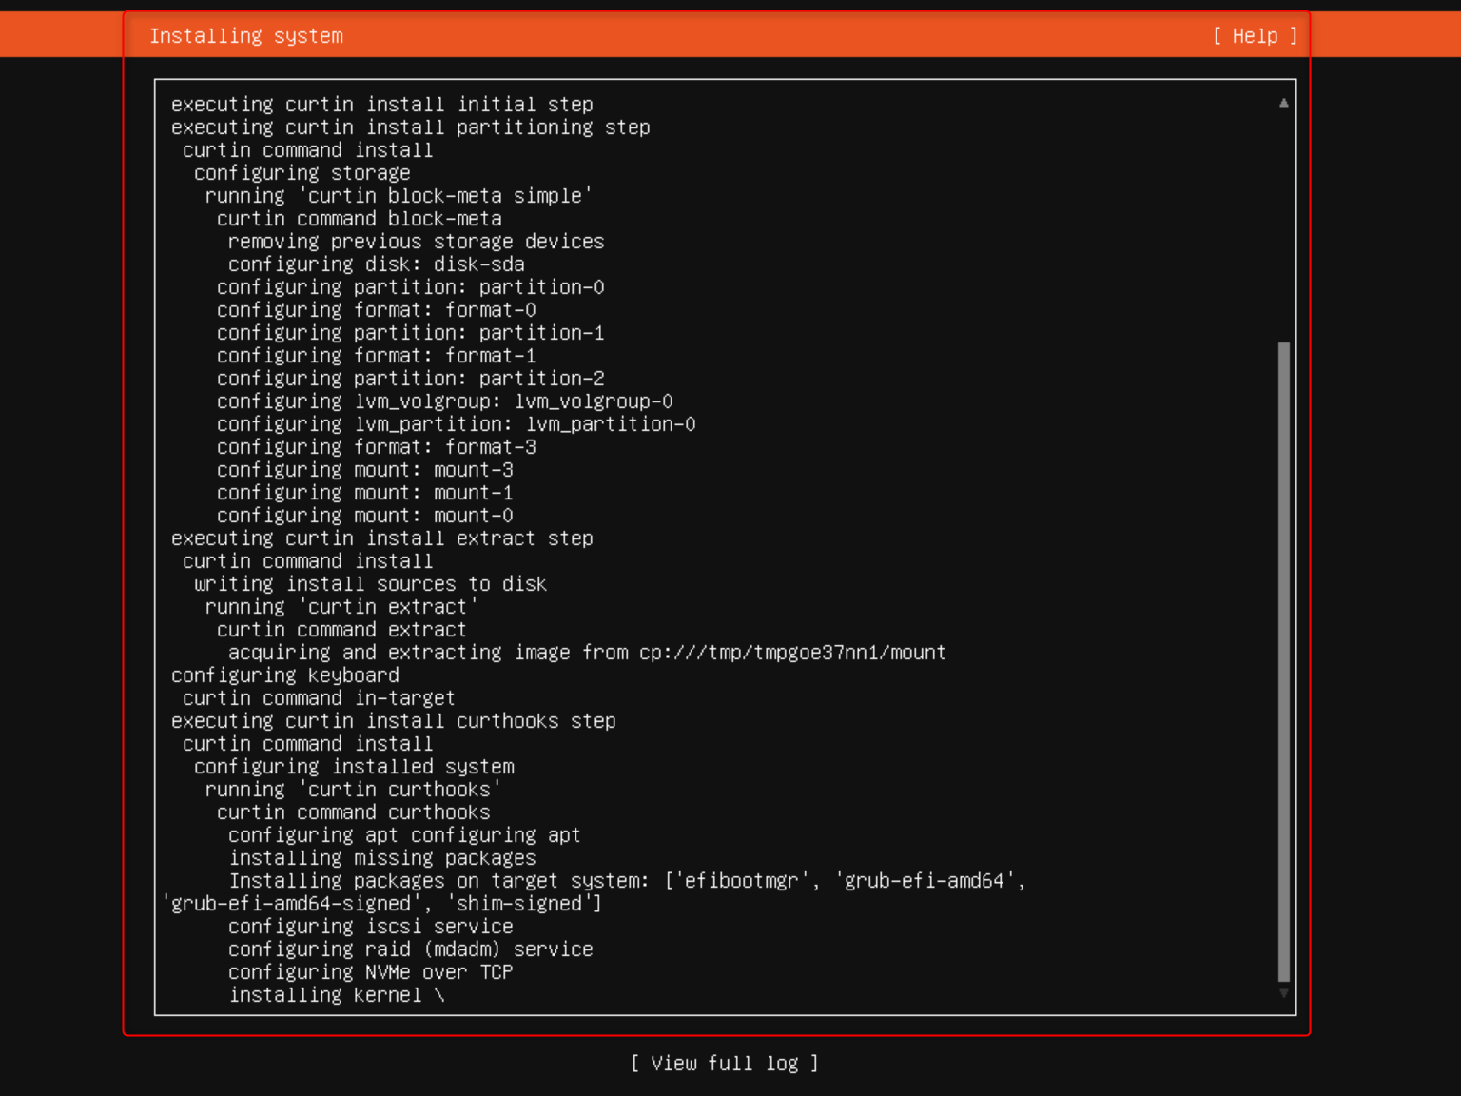

Choose Reboot to finish install
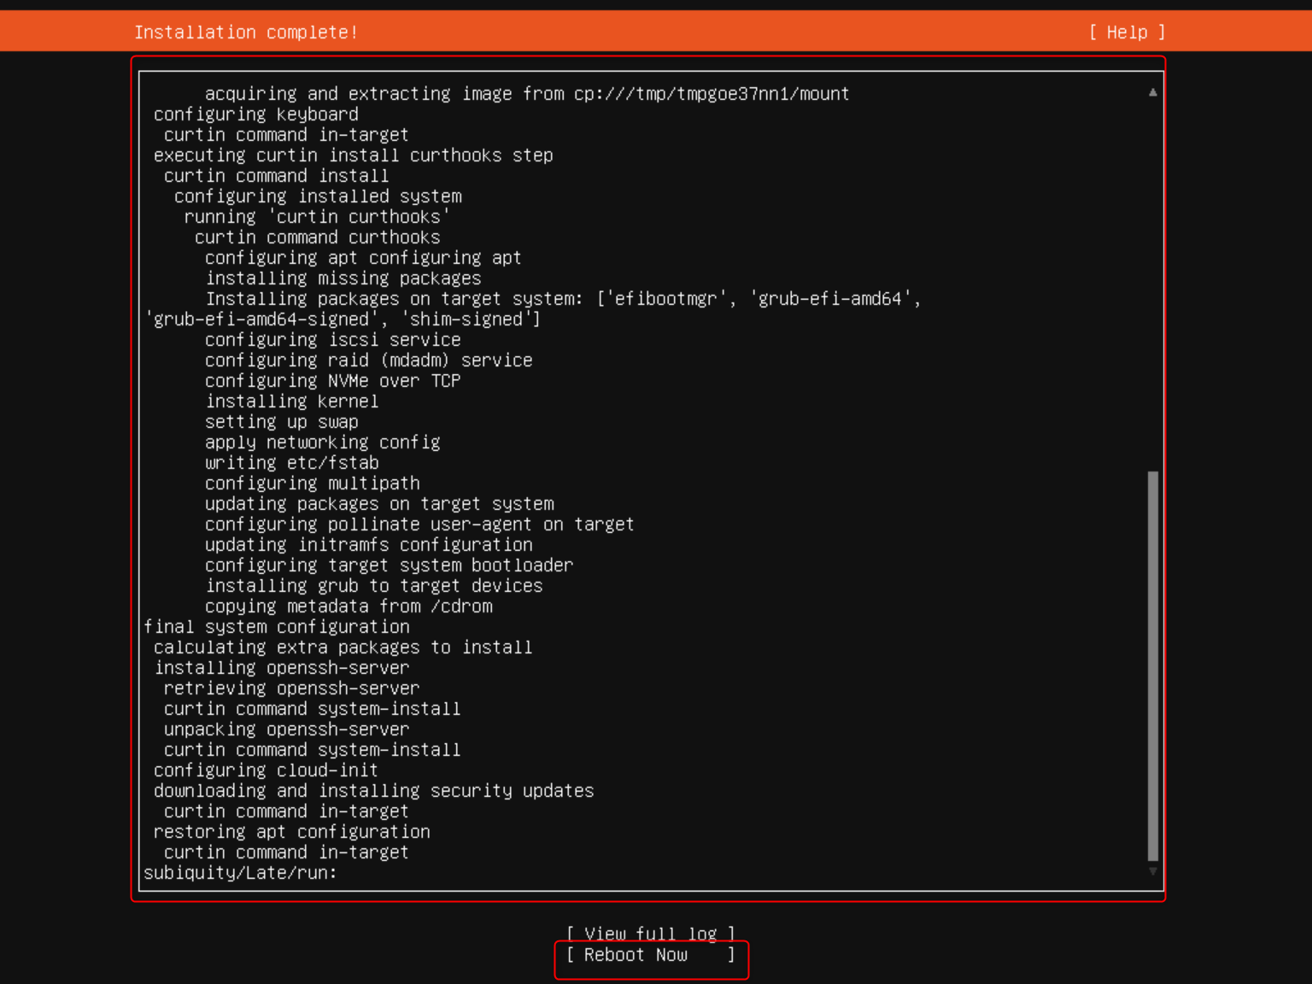


IV. Initial config for ubuntu server
1. Login server with MobaXterm
Open MobaXterm > Session > SSH > Input the Server IP and Username

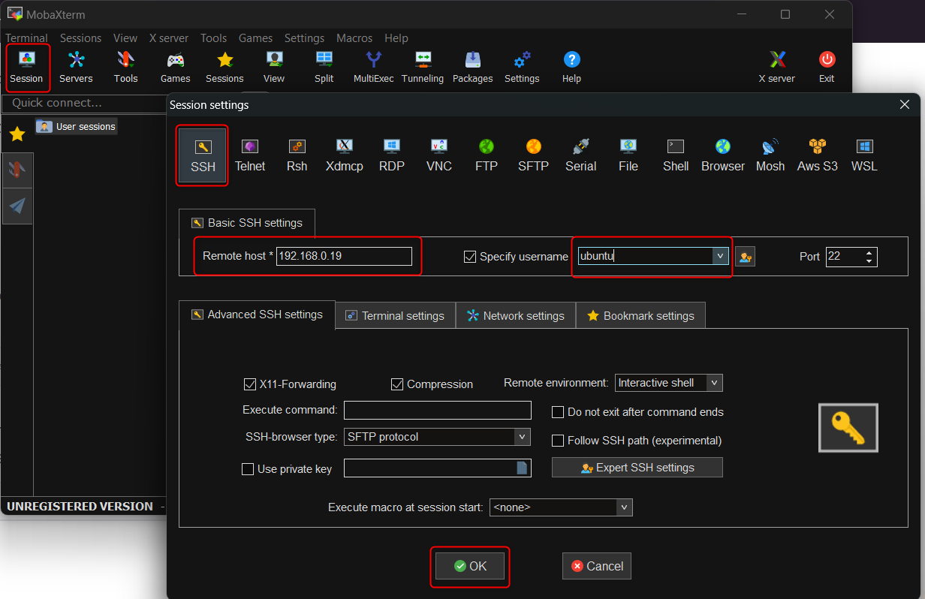

After input your password, you can login to server
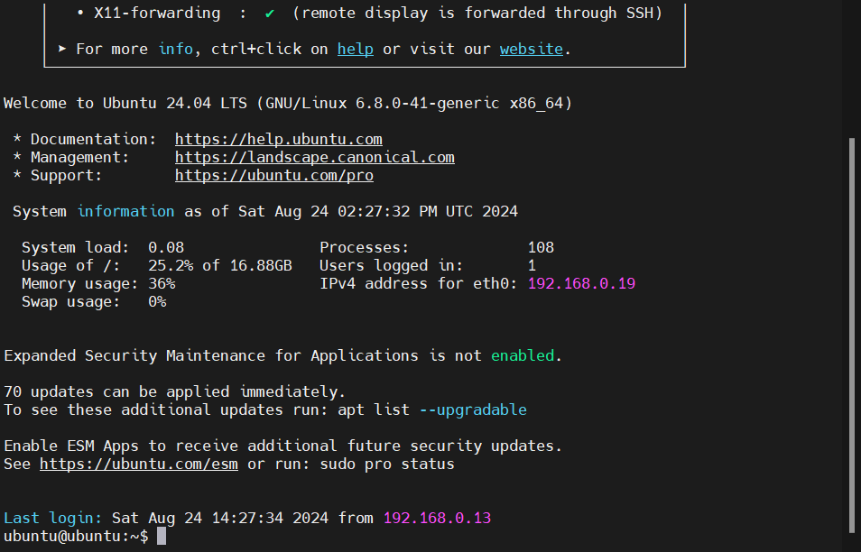

2. Configure using sudo without password
$ sudo vi /etc/sudoers.d/ubuntu
$ sudo cat /etc/sudoers.d/ubuntu
ubuntu ALL=(ALL:ALL) NOPASSWD: ALL

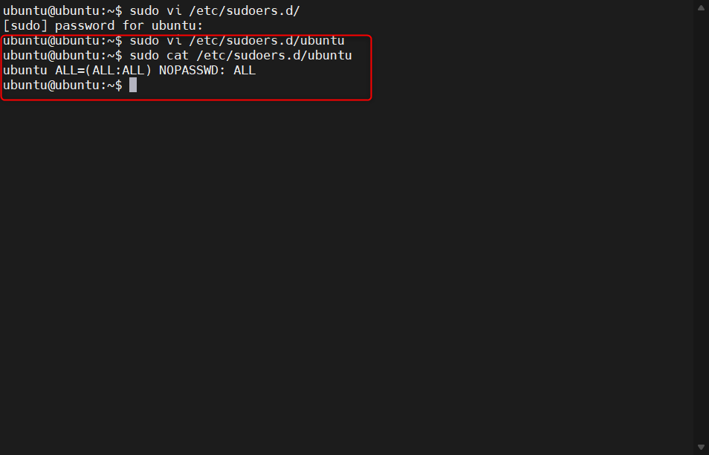

3. Configure ssh key to login without password
$ ssh-keygen
Generating public/private ed25519 key pair.
Enter file in which to save the key (/home/ubuntu/.ssh/id_ed25519): #Leave it blank
Enter passphrase (empty for no passphrase): #Leave it blank
Enter same passphrase again: #Leave it blank
Your identification has been saved in /home/ubuntu/.ssh/id_ed25519
Your public key has been saved in /home/ubuntu/.ssh/id_ed25519.pub
The key fingerprint is:
SHA256:JpnGDY1ZT2JcY+yIG2Z6HAEo017oXwJj+z9stDXPJxg ubuntu@ubuntu
The key's randomart image is:
+--[ED25519 256]--+
| . o.. .+o= |
|o B . .*.=.. |
| * = +o.o. |
| + ..B=. . |
| o B*+S |
| +.=oE |
| = o * |
| * . + . |
| . . o |
+----[SHA256]-----+

Private key and public key will be saved in folder “/home/ubuntu/.ssh”
~$ cd .ssh/
~/.ssh$ ll
total 16
drwx------ 2 ubuntu ubuntu 4096 Aug 24 14:39 ./
drwxr-x--- 4 ubuntu ubuntu 4096 Aug 24 14:28 ../
-rw------- 1 ubuntu ubuntu 0 Aug 24 14:11 authorized_keys
-rw------- 1 ubuntu ubuntu 399 Aug 24 14:39 id_ed25519
-rw-r--r-- 1 ubuntu ubuntu 95 Aug 24 14:39 id_ed25519.pub
~/.ssh$ pwd
/home/ubuntu/.ssh

Copy content of public key “id_ed25519.pub” to file “authorized_keys”
~/.ssh$ pwd
/home/ubuntu/.ssh
~/.ssh$ cat id_ed25519.pub
ssh-ed25519 AAAAC3NzaC1lZDI1NTE5AAAAIFxpAyrJi67hWeTWJk7uiEhoJULffn99HZKuDucq2Jad ubuntu@ubuntu
~/.ssh$ sudo vi authorized_keys
~/.ssh$ cat authorized_keys
ssh-ed25519 AAAAC3NzaC1lZDI1NTE5AAAAIFxpAyrJi67hWeTWJk7uiEhoJULffn99HZKuDucq2Jad ubuntu@ubuntu

Download private key to your PC
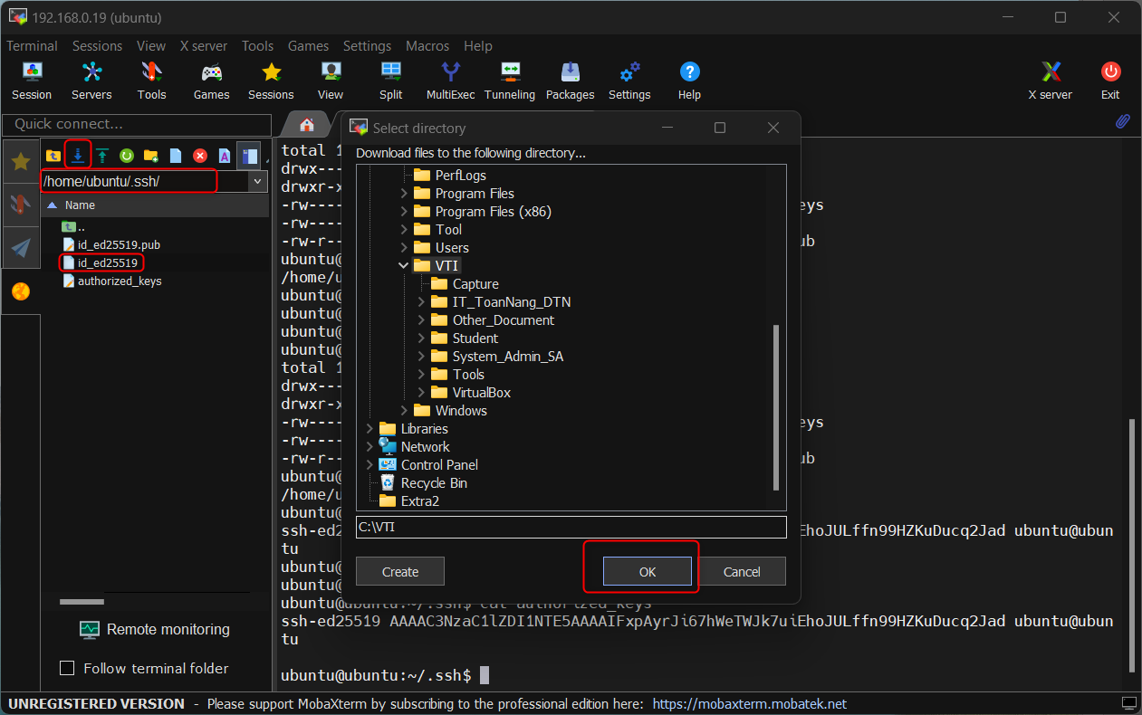

Set permission for the private key downloaded as image below
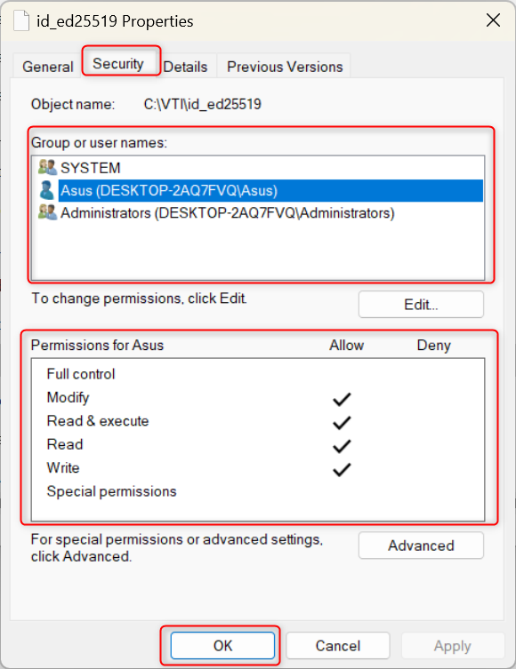

Right click on the connection just created above, choose “Advanced SSH Settings” > “Use private key” > Brower to the private key downloaded.
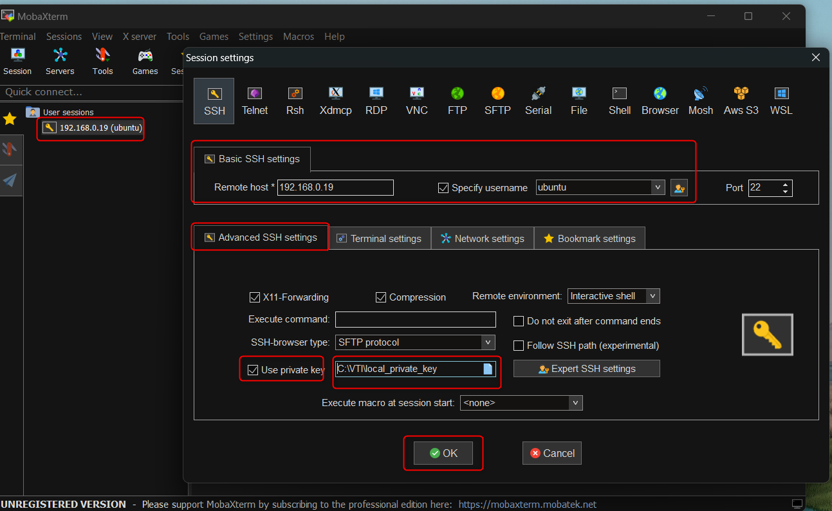

From now, you can login to server by double click to the session
